1. Logical

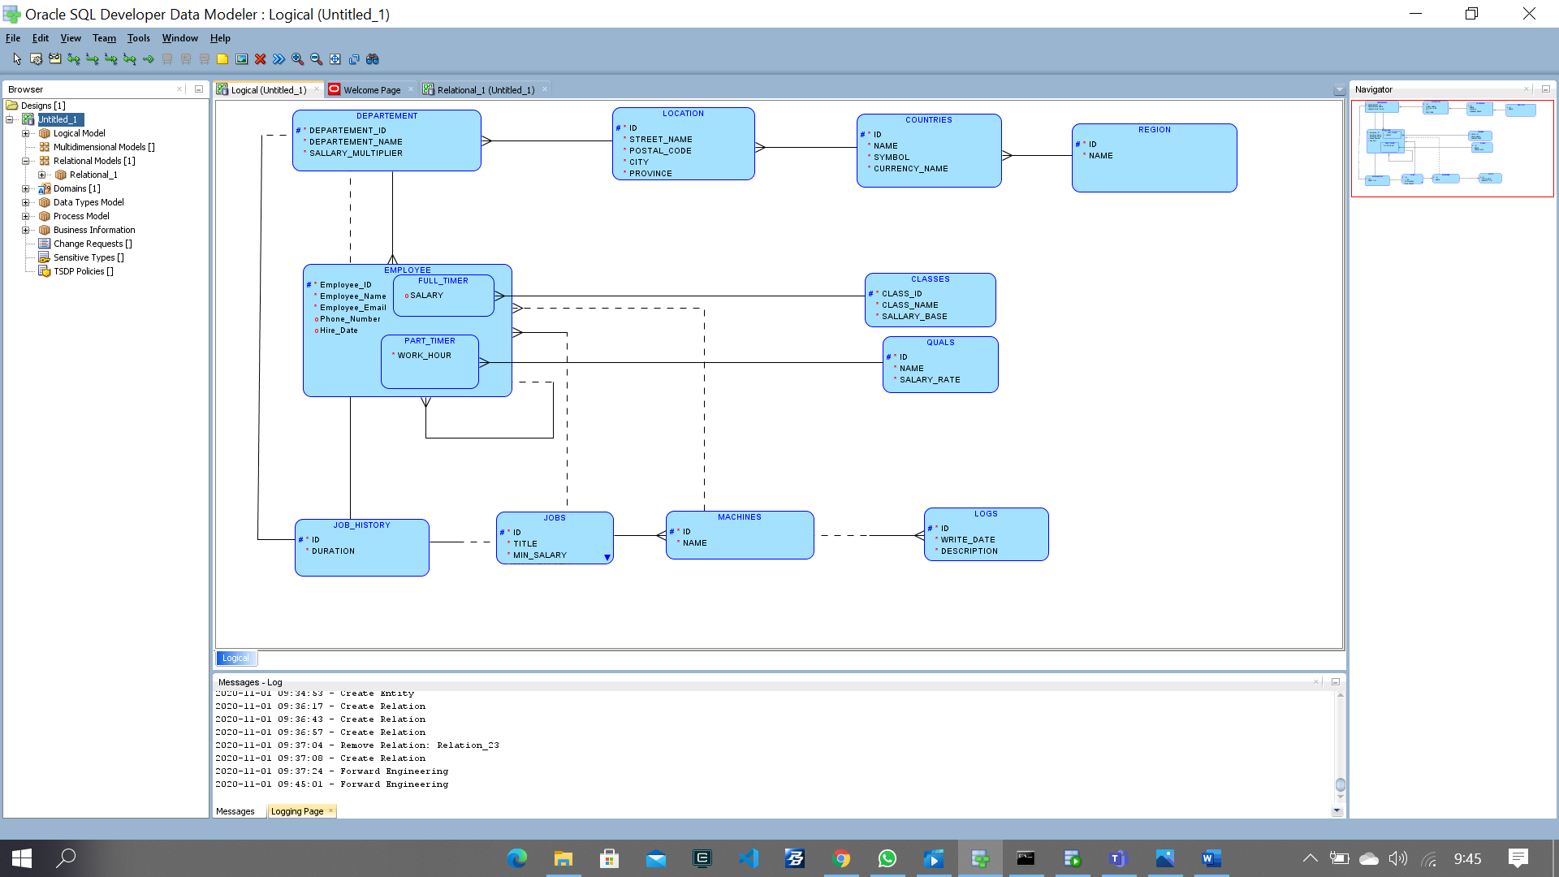

1. Reltaion

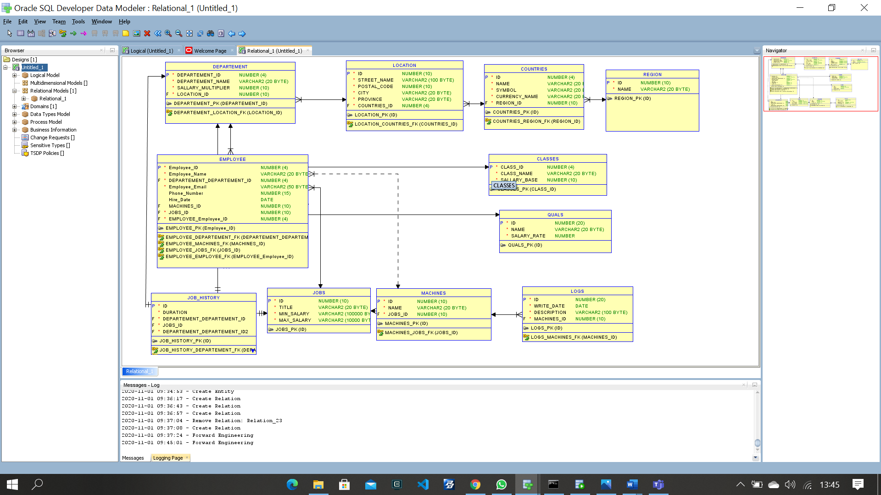

1. DDL

-- Generated by Oracle SQL Developer Data Modeler 20.2.0.167.1538

-- at: 2020-11-01 09:47:41 ICT

-- site: Oracle Database 11g

-- type: Oracle Database 11g

-- predefined type, no DDL - MDSYS.SDO_GEOMETRY

-- predefined type, no DDL - XMLTYPE

CREATE TABLE classes (

class_id NUMBER(4) NOT NULL,

class_name VARCHAR2(20 BYTE) NOT NULL,

sallary_base NUMBER(10) NOT NULL

);

ALTER TABLE classes ADD CONSTRAINT classes_pk PRIMARY KEY ( class_id );

CREATE TABLE countries (

id NUMBER(4) NOT NULL,

name VARCHAR2(20 BYTE) NOT NULL,

symbol VARCHAR2(20 BYTE) NOT NULL,

currency_name VARCHAR2(20 BYTE) NOT NULL,

region_id NUMBER(10) NOT NULL

);

ALTER TABLE countries ADD CONSTRAINT countries_pk PRIMARY KEY ( id );

CREATE TABLE departement (

departement_id NUMBER(4) NOT NULL,

departement_name VARCHAR2(20 BYTE) NOT NULL,

sallary_multiplier NUMBER(10) NOT NULL,

location_id NUMBER(10) NOT NULL

);

ALTER TABLE departement ADD CONSTRAINT departement_pk PRIMARY KEY ( departement_id );

CREATE TABLE employee (

employee_id NUMBER(4) NOT NULL,

employee_name VARCHAR2(20 BYTE) NOT NULL,

departement_departement_id NUMBER(4) NOT NULL,

employee_email VARCHAR2(50 BYTE) NOT NULL,

phone_number NUMBER(15),

hire_date DATE,

machines_id NUMBER(10),

jobs_id NUMBER(10) NOT NULL,

employee_employee_id NUMBER(4) NOT NULL

);

ALTER TABLE employee ADD CONSTRAINT employee_pk PRIMARY KEY ( employee_id );

CREATE TABLE full_timer (

employee_id NUMBER(4) NOT NULL,

salary NUMBER(20),

classes_class_id NUMBER(4) NOT NULL

);

ALTER TABLE full_timer ADD CONSTRAINT part_timer_pk PRIMARY KEY ( employee_id );

CREATE TABLE job_history (

id NUMBER(10) NOT NULL,

duration NUMBER(10) NOT NULL,

departement_departement_id NUMBER(4) NOT NULL,

jobs_id NUMBER(10) NOT NULL,

departement_departement_id2 NUMBER(4) NOT NULL

);

CREATE UNIQUE INDEX job_history__idx ON

job_history (

departement_departement_id

ASC );

CREATE UNIQUE INDEX job_history__idxv1 ON

job_history (

jobs_id

ASC );

CREATE UNIQUE INDEX job_history__idxv2 ON

job_history (

departement_departement_id2

ASC );

ALTER TABLE job_history ADD CONSTRAINT job_history_pk PRIMARY KEY ( id );

CREATE TABLE jobs (

id NUMBER(10) NOT NULL,

title VARCHAR2(20 BYTE) NOT NULL,

min_salary VARCHAR2(100000 BYTE) NOT NULL,

max_salary VARCHAR2(10000 BYTE) NOT NULL

);

ALTER TABLE jobs ADD CONSTRAINT jobs_pk PRIMARY KEY ( id );

CREATE TABLE location (

id NUMBER(10) NOT NULL,

street_name VARCHAR2(100 BYTE) NOT NULL,

postal_code NUMBER(10) NOT NULL,

city VARCHAR2(20 BYTE) NOT NULL,

province VARCHAR2(20 BYTE) NOT NULL,

countries_id NUMBER(4) NOT NULL

);

ALTER TABLE location ADD CONSTRAINT location_pk PRIMARY KEY ( id );

CREATE TABLE logs (

id NUMBER(20) NOT NULL,

write_date DATE NOT NULL,

description VARCHAR2(100 BYTE) NOT NULL,

machines_id NUMBER(10) NOT NULL

);

ALTER TABLE logs ADD CONSTRAINT logs_pk PRIMARY KEY ( id );

CREATE TABLE machines (

id NUMBER(10) NOT NULL,

name VARCHAR2(20 BYTE) NOT NULL,

jobs_id NUMBER(10) NOT NULL

);

ALTER TABLE machines ADD CONSTRAINT machines_pk PRIMARY KEY ( id );

CREATE TABLE part_timer (

employee_id1 NUMBER(4) NOT NULL,

work_hour NUMBER(24) NOT NULL,

quals_id NUMBER(20) NOT NULL

);

ALTER TABLE part_timer ADD CONSTRAINT part_timer_pkv1 PRIMARY KEY ( employee_id1 );

CREATE TABLE quals (

id NUMBER(20) NOT NULL,

name VARCHAR2(20 BYTE) NOT NULL,

salary_rate NUMBER NOT NULL

);

ALTER TABLE quals ADD CONSTRAINT quals_pk PRIMARY KEY ( id );

CREATE TABLE region (

id NUMBER(10) NOT NULL,

name VARCHAR2(20 BYTE) NOT NULL

);

ALTER TABLE region ADD CONSTRAINT region_pk PRIMARY KEY ( id );

ALTER TABLE countries

ADD CONSTRAINT countries_region_fk FOREIGN KEY ( region_id )

REFERENCES region ( id );

ALTER TABLE departement

ADD CONSTRAINT departement_location_fk FOREIGN KEY ( location_id )

REFERENCES location ( id );

ALTER TABLE employee

ADD CONSTRAINT employee_departement_fk FOREIGN KEY ( departement_departement_id )

REFERENCES departement ( departement_id );

ALTER TABLE employee

ADD CONSTRAINT employee_employee_fk FOREIGN KEY ( employee_employee_id )

REFERENCES employee ( employee_id );

ALTER TABLE employee

ADD CONSTRAINT employee_jobs_fk FOREIGN KEY ( jobs_id )

REFERENCES jobs ( id );

ALTER TABLE employee

ADD CONSTRAINT employee_machines_fk FOREIGN KEY ( machines_id )

REFERENCES machines ( id );

ALTER TABLE full_timer

ADD CONSTRAINT full_timer_classes_fk FOREIGN KEY ( classes_class_id )

REFERENCES classes ( class_id );

ALTER TABLE job_history

ADD CONSTRAINT job_history_departement_fk FOREIGN KEY ( departement_departement_id )

REFERENCES departement ( departement_id );

ALTER TABLE job_history

ADD CONSTRAINT job_history_departement_fkv1 FOREIGN KEY ( departement_departement_id2 )

REFERENCES departement ( departement_id );

ALTER TABLE job_history

ADD CONSTRAINT job_history_jobs_fk FOREIGN KEY ( jobs_id )

REFERENCES jobs ( id );

ALTER TABLE location

ADD CONSTRAINT location_countries_fk FOREIGN KEY ( countries_id )

REFERENCES countries ( id );

ALTER TABLE logs

ADD CONSTRAINT logs_machines_fk FOREIGN KEY ( machines_id )

REFERENCES machines ( id );

ALTER TABLE machines

ADD CONSTRAINT machines_jobs_fk FOREIGN KEY ( jobs_id )

REFERENCES jobs ( id );

ALTER TABLE full_timer

ADD CONSTRAINT part_timer_employee_fk FOREIGN KEY ( employee_id )

REFERENCES employee ( employee_id );

ALTER TABLE part_timer

ADD CONSTRAINT part_timer_employee_fkv2 FOREIGN KEY ( employee_id1 )

REFERENCES employee ( employee_id );

ALTER TABLE part_timer

ADD CONSTRAINT part_timer_quals_fk FOREIGN KEY ( quals_id )

REFERENCES quals ( id );

-- ERROR: No Discriminator Column found in Arc FKArc_1 - constraint trigger for Arc cannot be generated

-- ERROR: No Discriminator Column found in Arc FKArc_1 - constraint trigger for Arc cannot be generated

-- Oracle SQL Developer Data Modeler Summary Report:

--

-- CREATE TABLE 13

-- CREATE INDEX 3

-- ALTER TABLE 29

-- CREATE VIEW 0

-- ALTER VIEW 0

-- CREATE PACKAGE 0

-- CREATE PACKAGE BODY 0

-- CREATE PROCEDURE 0

-- CREATE FUNCTION 0

-- CREATE TRIGGER 0

-- ALTER TRIGGER 0

-- CREATE COLLECTION TYPE 0

-- CREATE STRUCTURED TYPE 0

-- CREATE STRUCTURED TYPE BODY 0

-- CREATE CLUSTER 0

-- CREATE CONTEXT 0

-- CREATE DATABASE 0

-- CREATE DIMENSION 0

-- CREATE DIRECTORY 0

-- CREATE DISK GROUP 0

-- CREATE ROLE 0

-- CREATE ROLLBACK SEGMENT 0

-- CREATE SEQUENCE 0

-- CREATE MATERIALIZED VIEW 0

-- CREATE MATERIALIZED VIEW LOG 0

-- CREATE SYNONYM 0

-- CREATE TABLESPACE 0

-- CREATE USER 0

--

-- DROP TABLESPACE 0

-- DROP DATABASE 0

--

-- REDACTION POLICY 0

--

-- ORDS DROP SCHEMA 0

-- ORDS ENABLE SCHEMA 0

-- ORDS ENABLE OBJECT 0

--

-- ERRORS 2

-- WARNINGS 0

1. Tables :

* classes

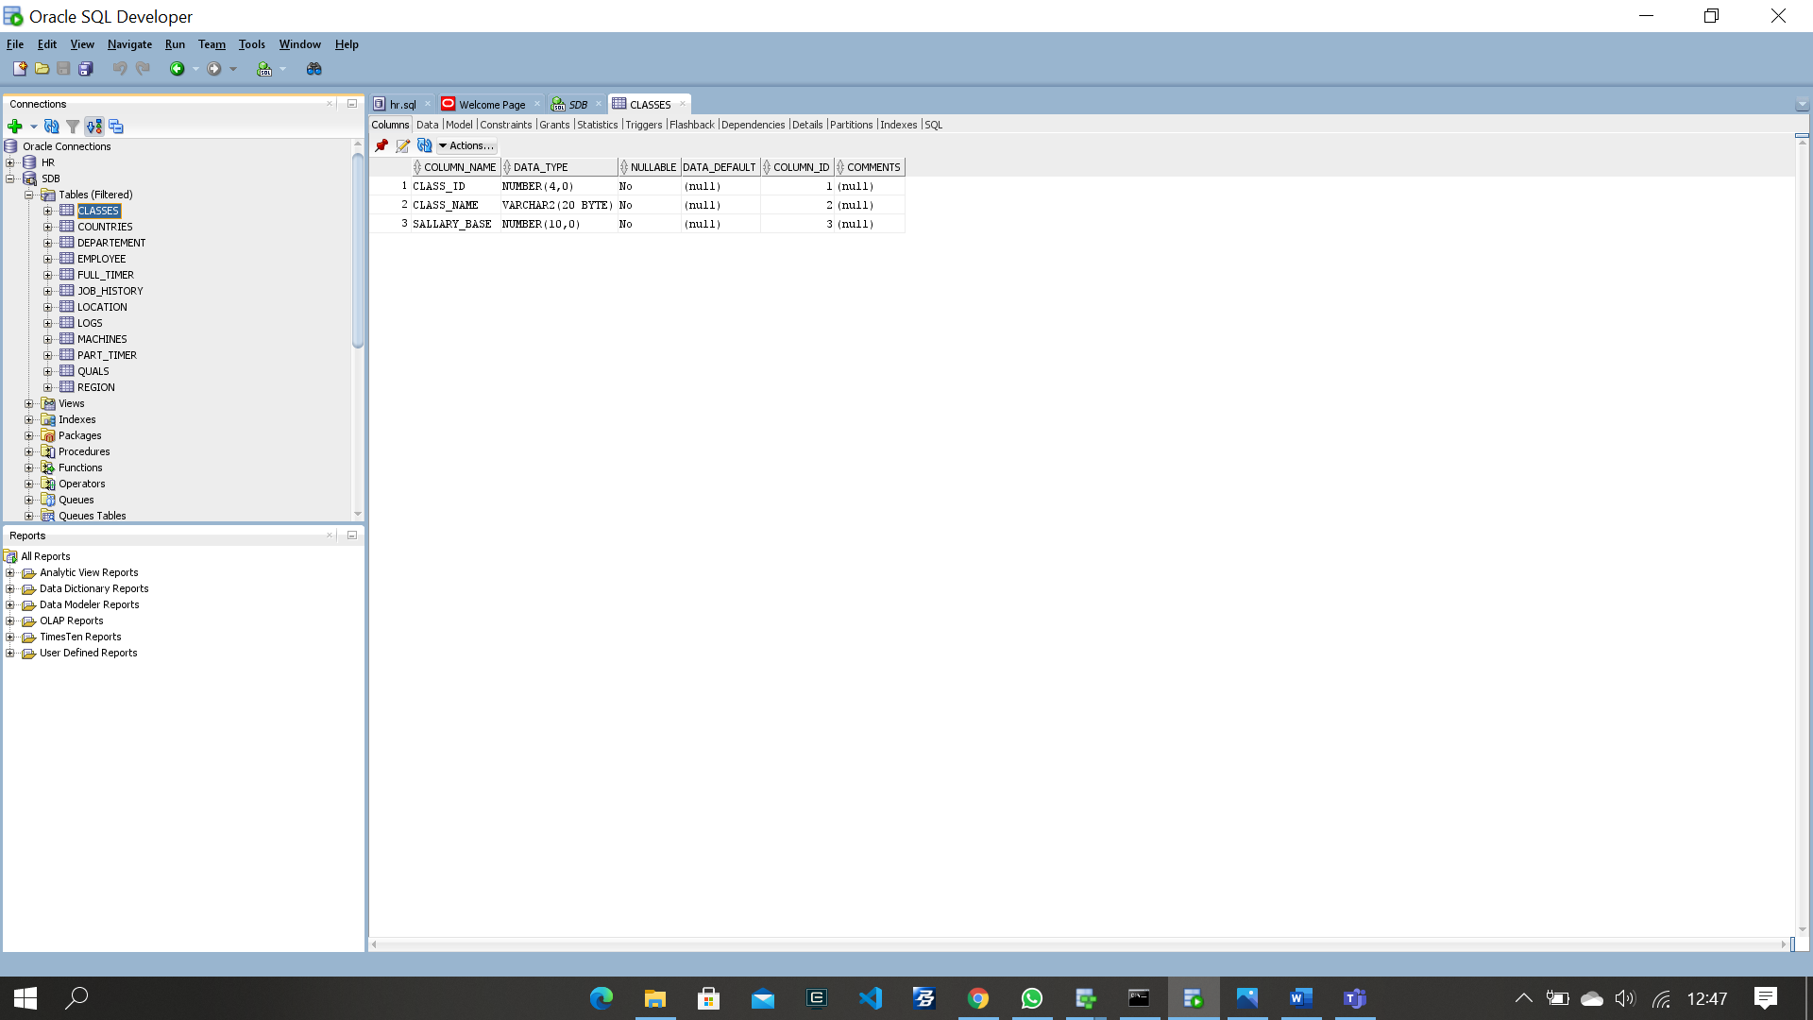

* Countries

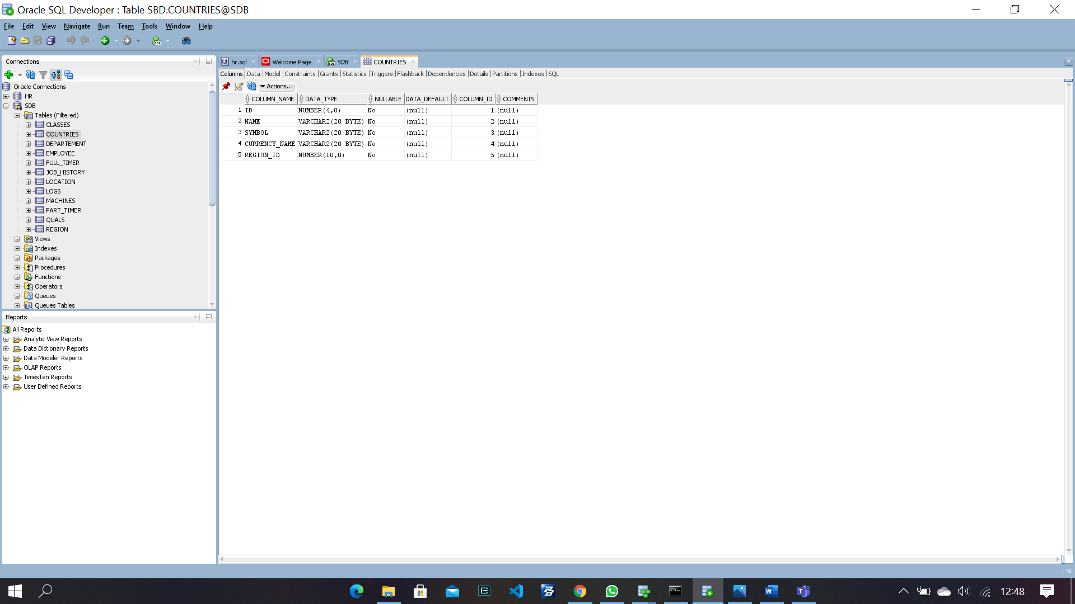

* Departement

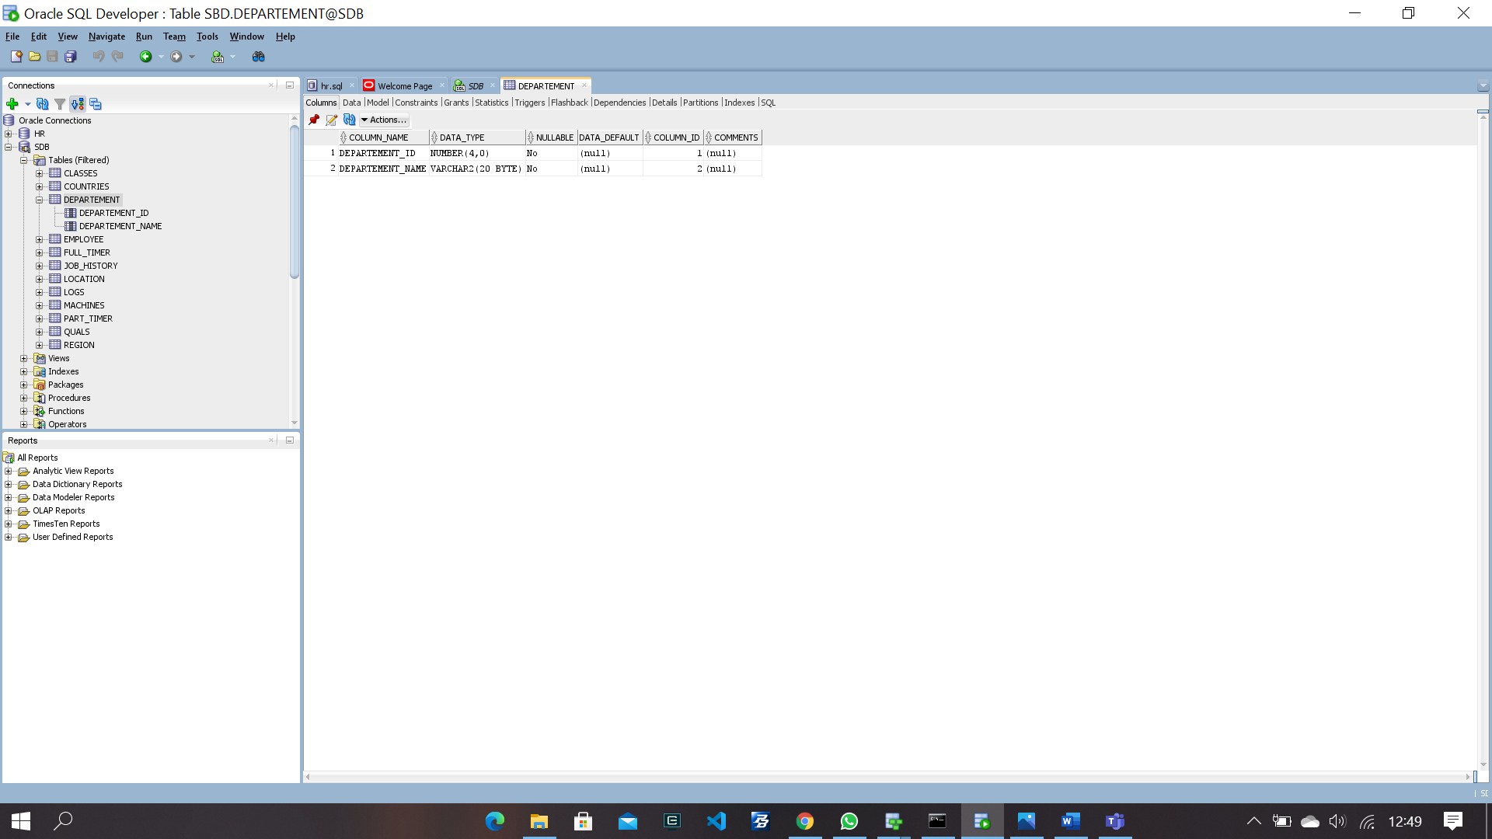

* Employee

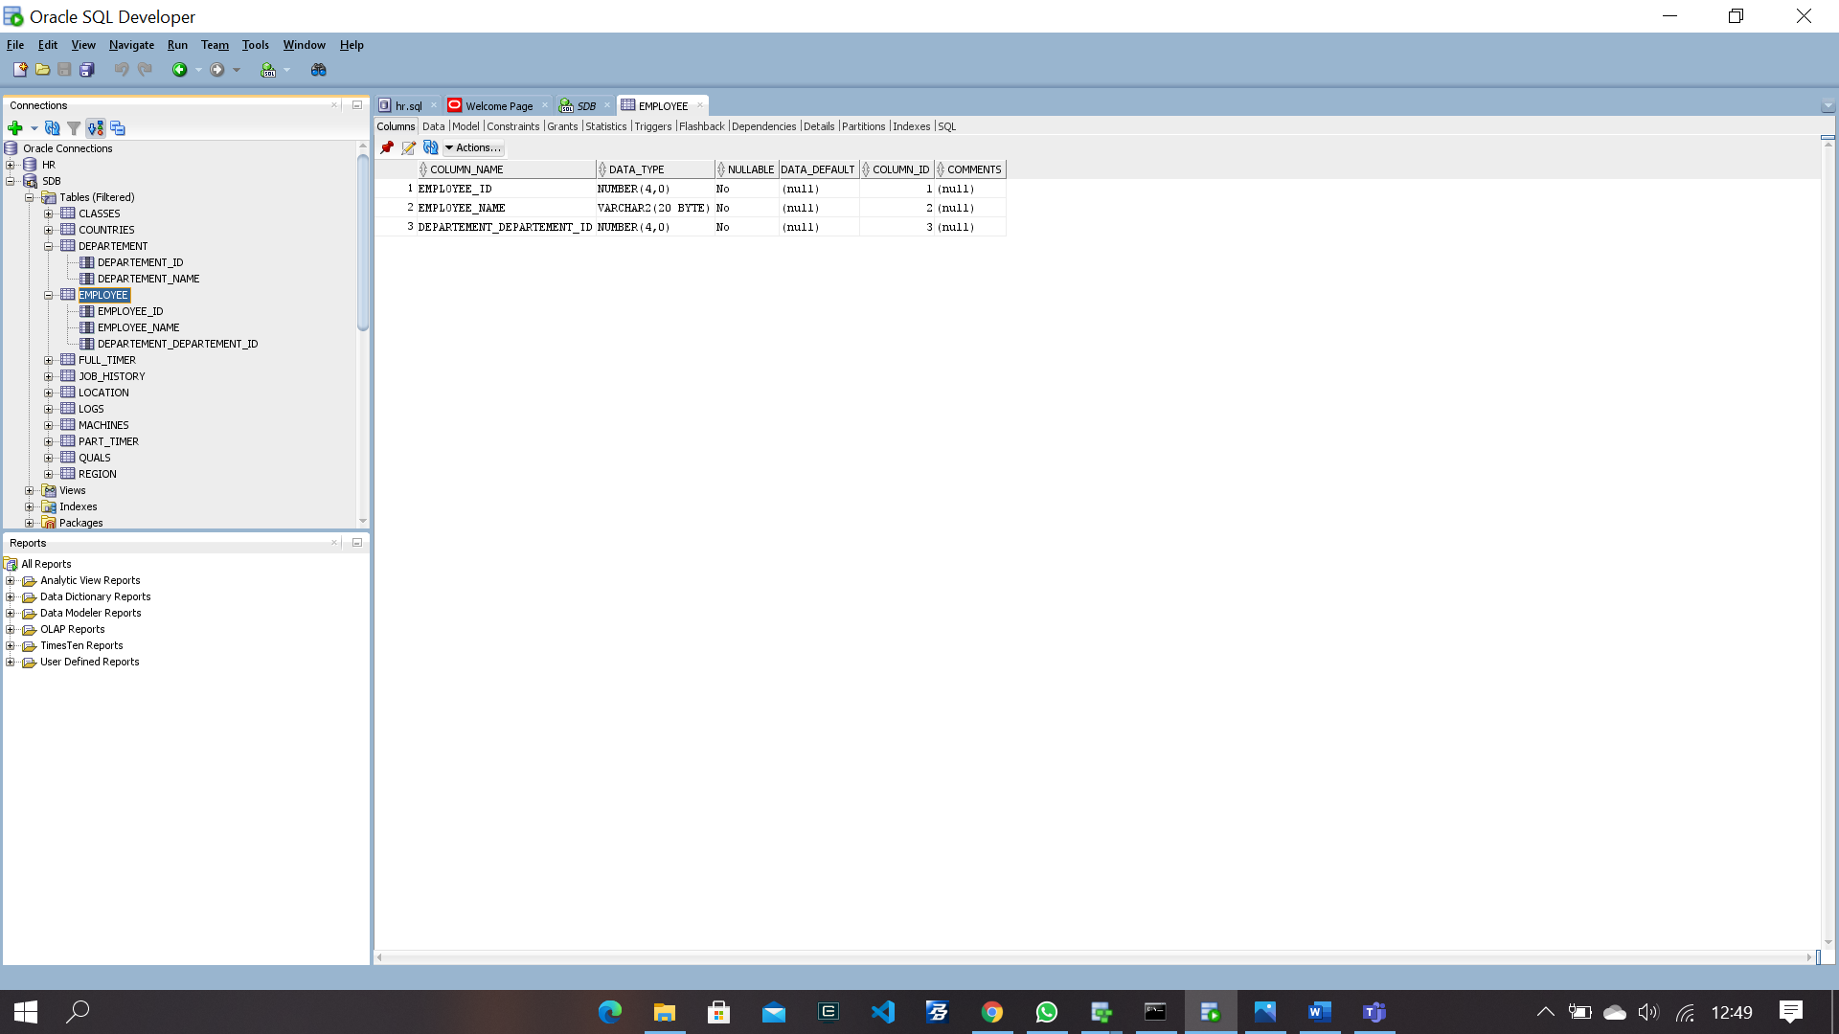

* Full Timer

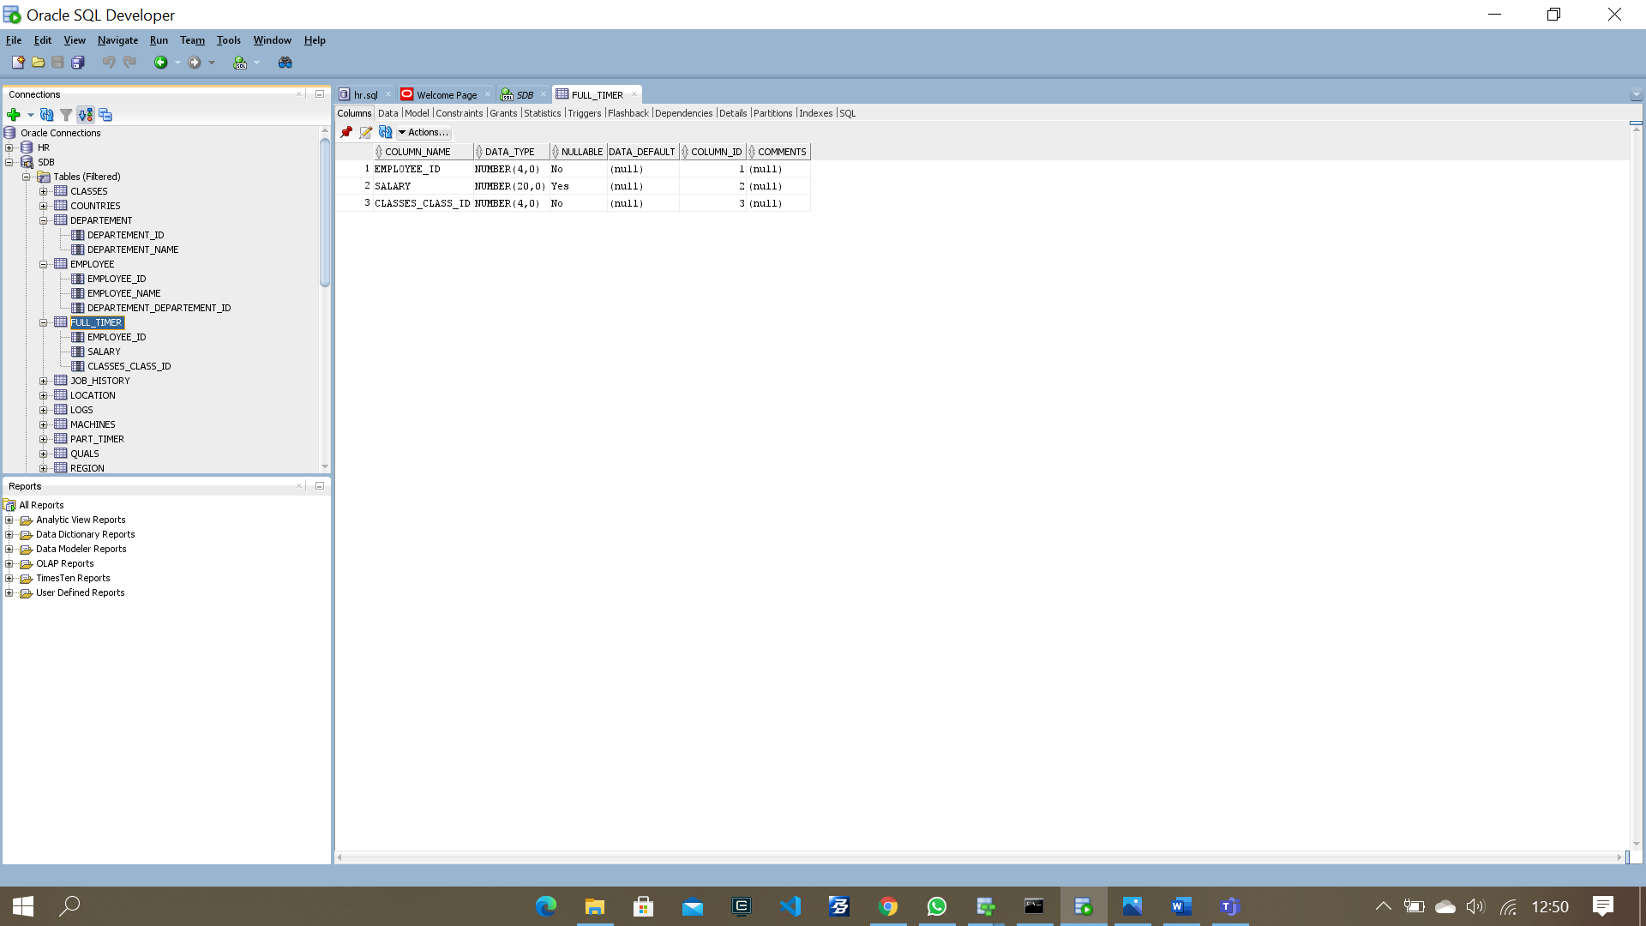

* Job History

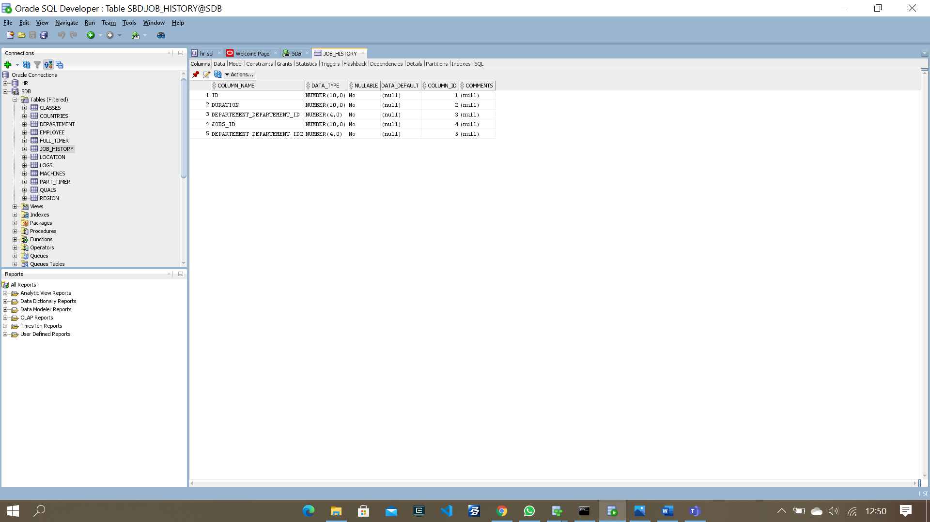

* Location

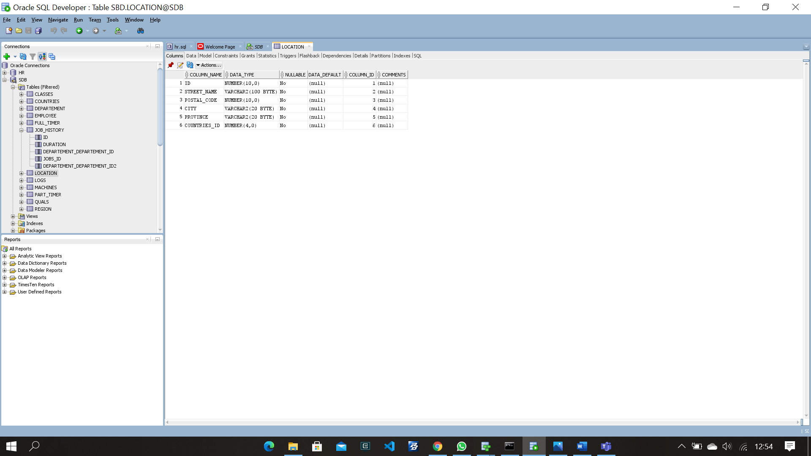

* Logs

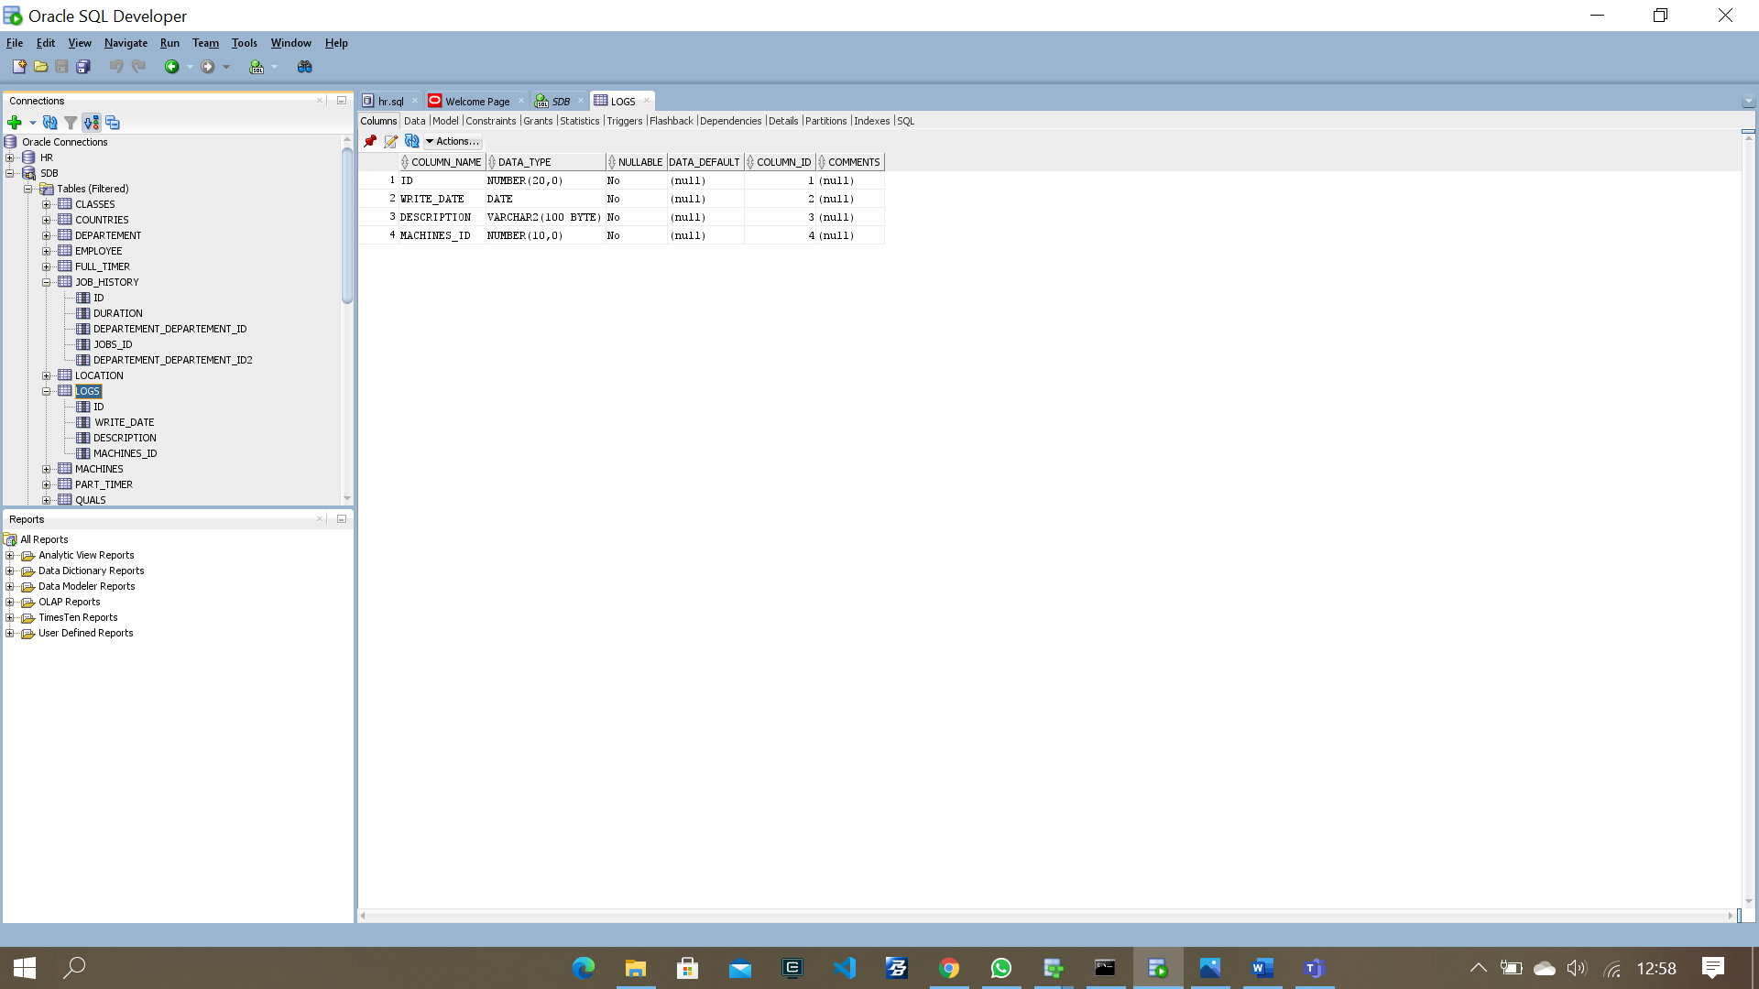

* Machines

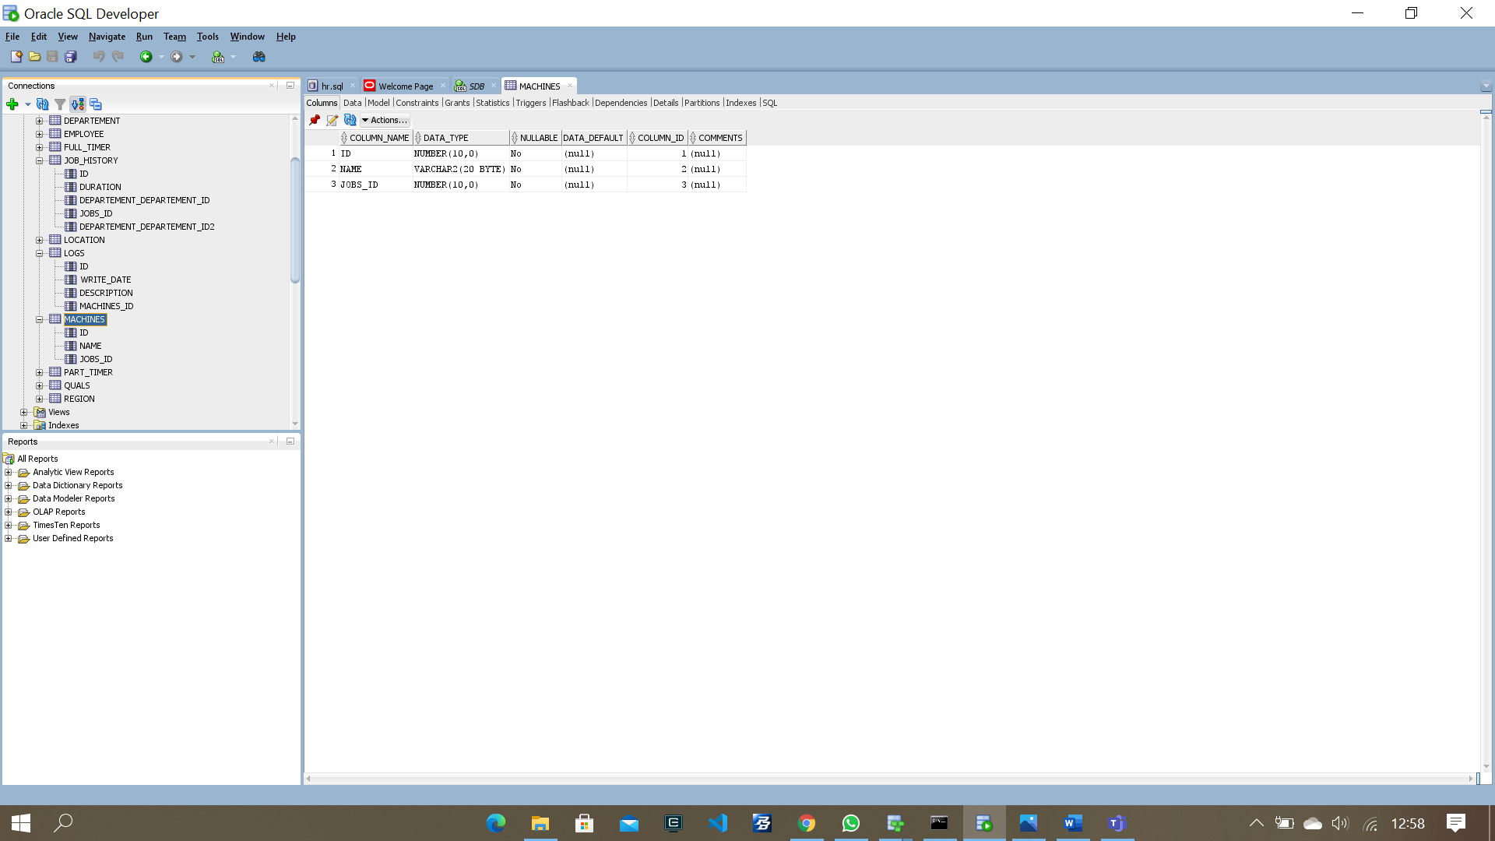

* Part Timer

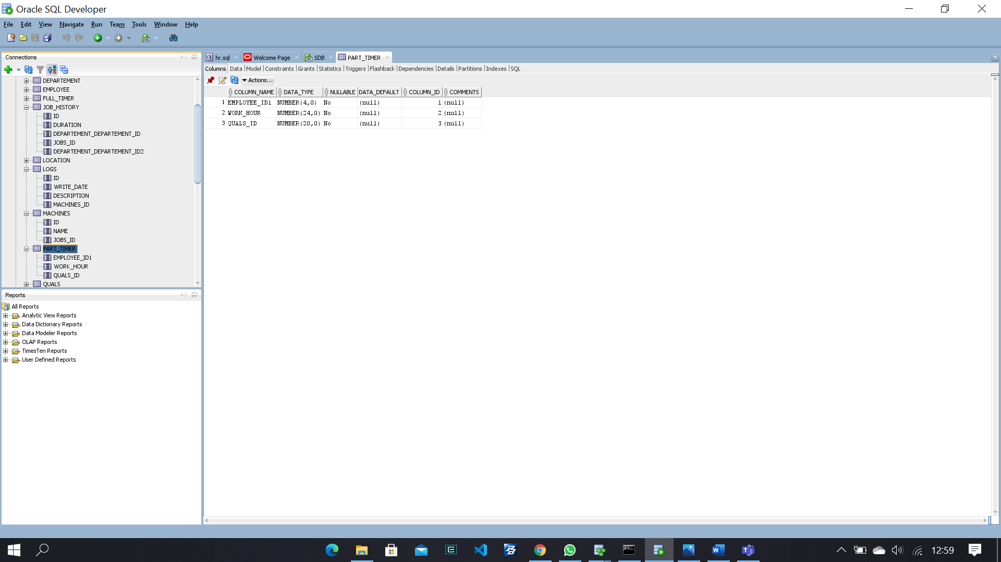

* Quals

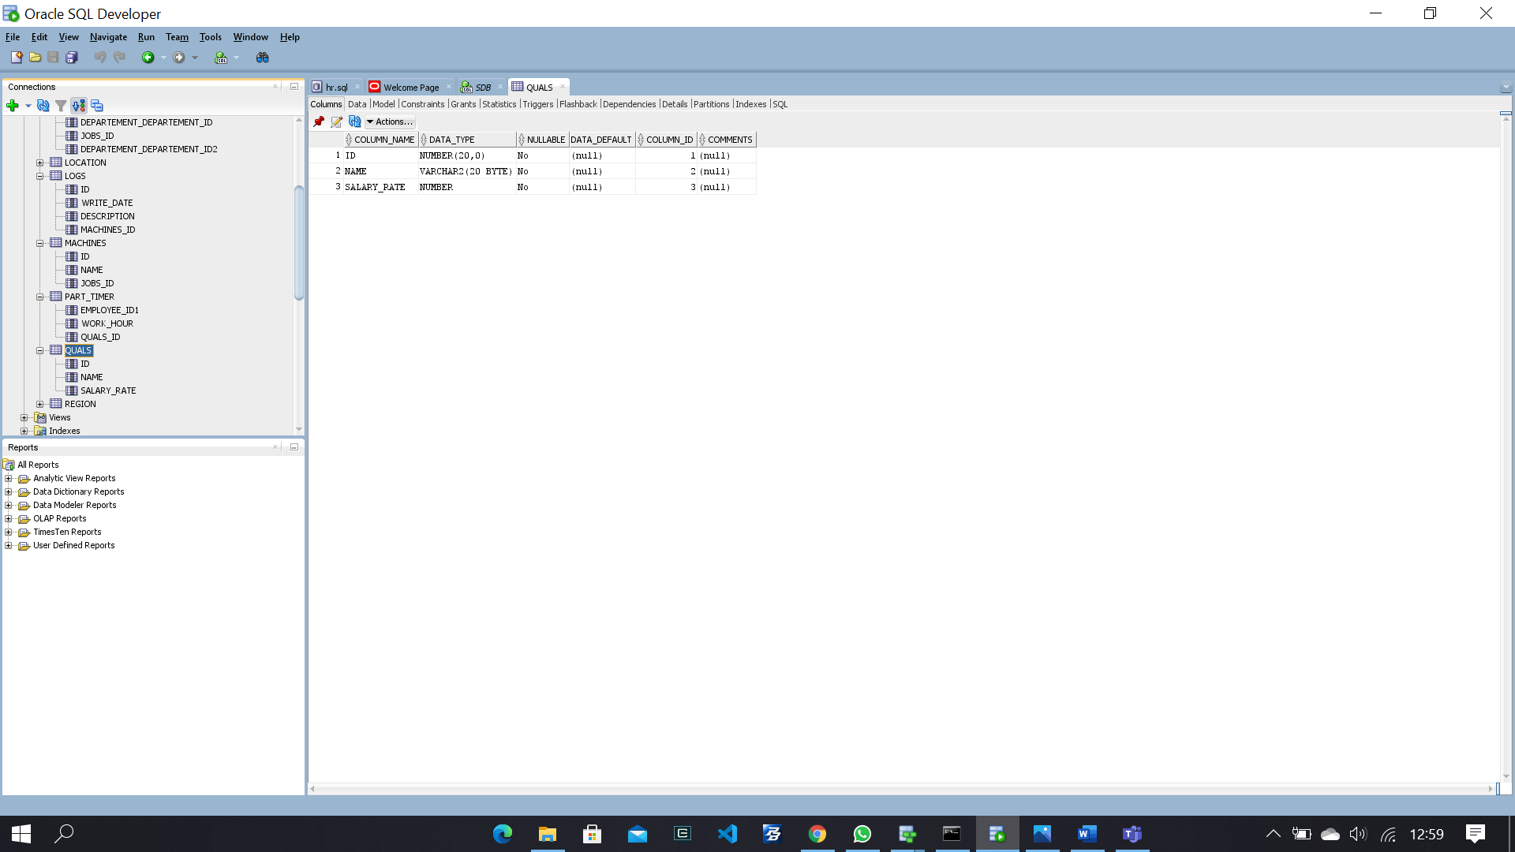

* Region